24th January 2018

**YOKOHAMA’s New Flange Opening Enables Hassle-Free Inspection of Safety Valves of Vertical Pneumatic Fenders**

YOKOHAMA started sales in January 2018 of a newly developed flange opening that facilitates the inspection of safety valves with a hassle-free procedure.  
  
The pneumatic fender is a rubber cushioning product inflated with air, and floated between two ships or between a ship and a quay wall, for the purpose of preventing damage to the hull and the quay wall during ship-to-ship operations or when ships are moored. Vertical pneumatic fenders are used with submarines or other vessels whose hull or part thereof is submerged deeper below the water line than that of conventional vessels.  
  
Pneumatic fenders are fitted with safety valves that release air from inside the fender, preventing rupture when internal pressure becomes excessive. Conventionally, inspection of the safety valve is an extremely costly process that requires landing the pneumatic fender with a crane, removing the air, and then removing the safety valve together with its flange opening. The new fittings developed by YOKOHAMA are structured so that air passage between the fender's body and the flange opening can be blocked by manually closing the valve, thus ensuring the fender body remains airtight. This enables inspection of the safety valve while it is equipped on to the fender, significantly reducing downtime and maintenance costs.  
  
YOKOHAMA is one of the world's leading manufacturers of pneumatic fenders, marine hoses and other products for the marine equipment market. YOKOHAMA was the world’s first company to manufacture and sell rubber-based pneumatic marine fenders. Since their launch in 1958, these products have become essential to at-sea ship-to-ship transfers of crude oil, LPG, and other crucial cargo.

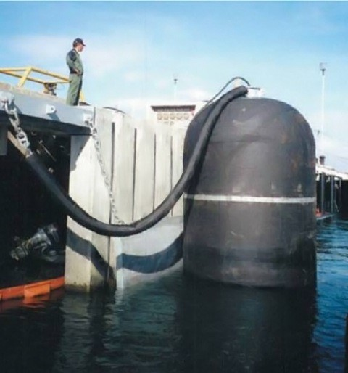

*Vertical pneumatic fender*

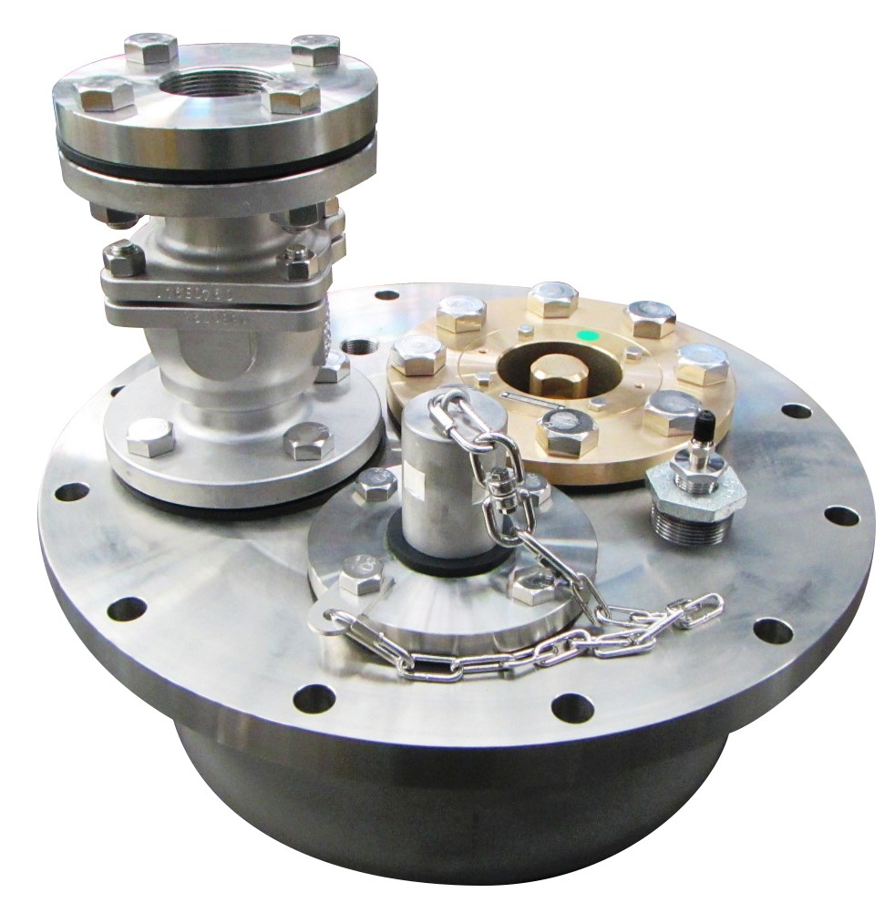

*New flange*